Spark Submit

Download and pull to Sandbox home directory

* Code/Dataset

data/spark-submit.zip

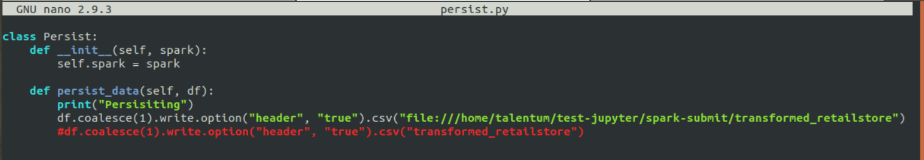

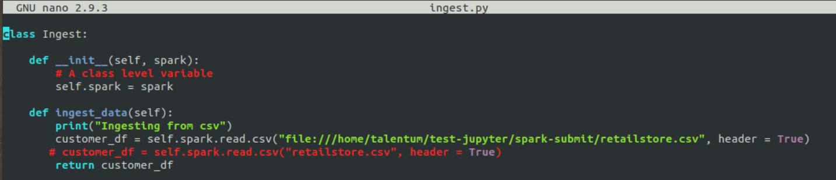

Start Hadoop

Check processes

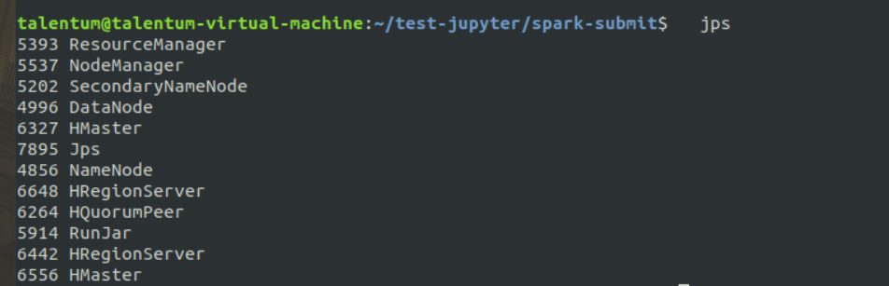

Now see description of below commands

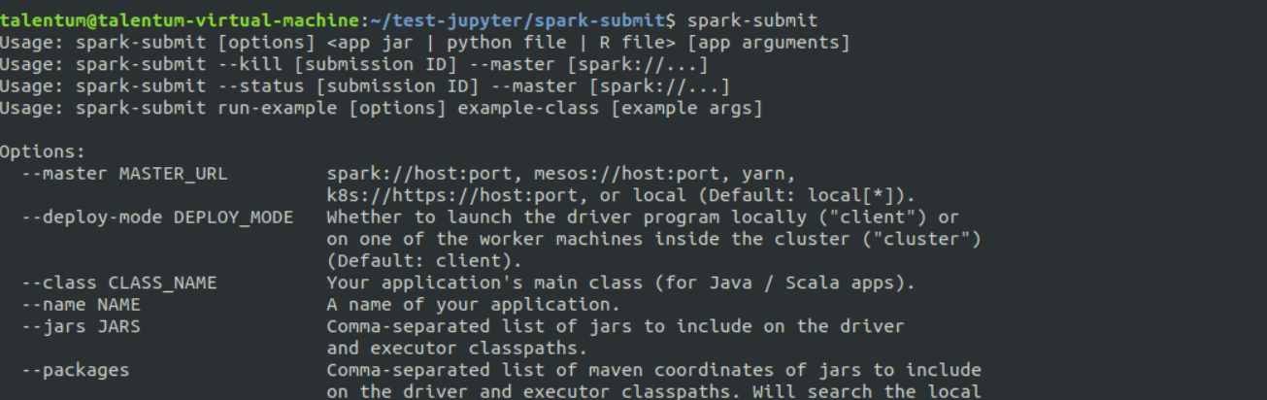

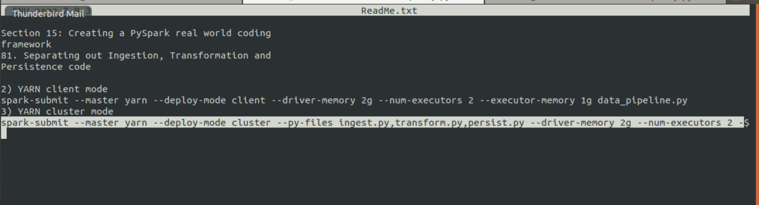

**Run this command**

**Yarn logs -applicationID application(id)**

**Then run unset file**

**And rerun command again**

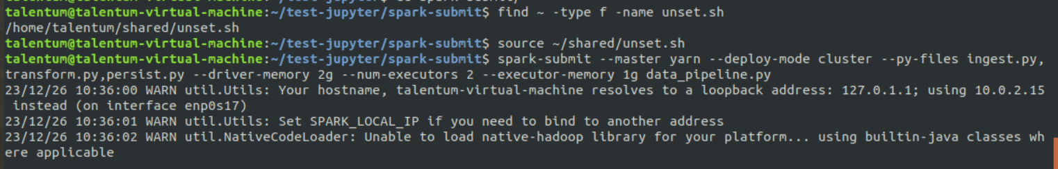

**find ~ -type f -name unset.sh**

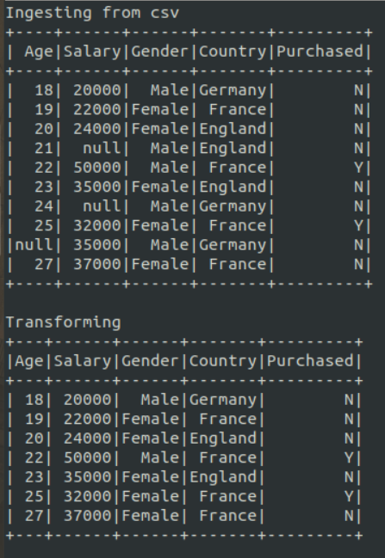

**Run client mode command**

**spark-submit --master yarn --deploy-mode client --driver-memory 2g --num-executors 2 --executor-memory 1g data_pipeline.py**

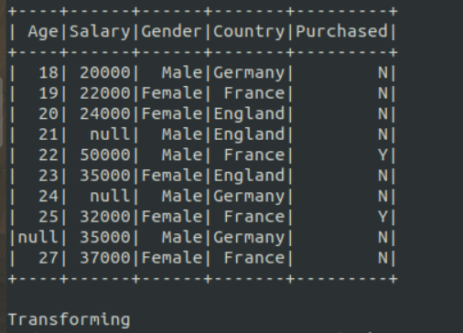

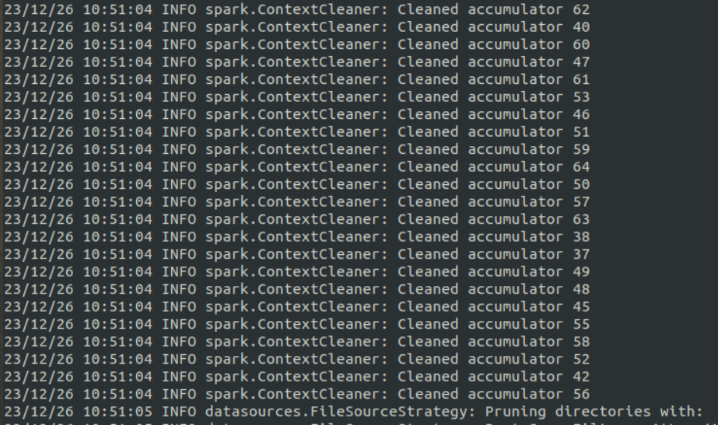

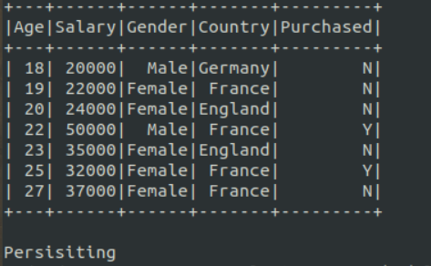

**spark-submit --master yarn --deploy-mode cluster --driver-memory 2g --num-executors 2 --executor-memory 1g data_pipeline.py**

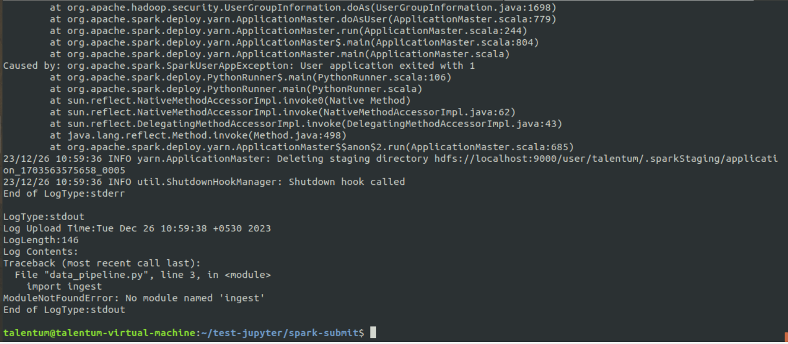

**spark-submit --master yarn --deploy-mode cluster --py-files ingest.py --driver-memory 2g --num-executors 2 --executor-memory 1g data_pipeline.py**

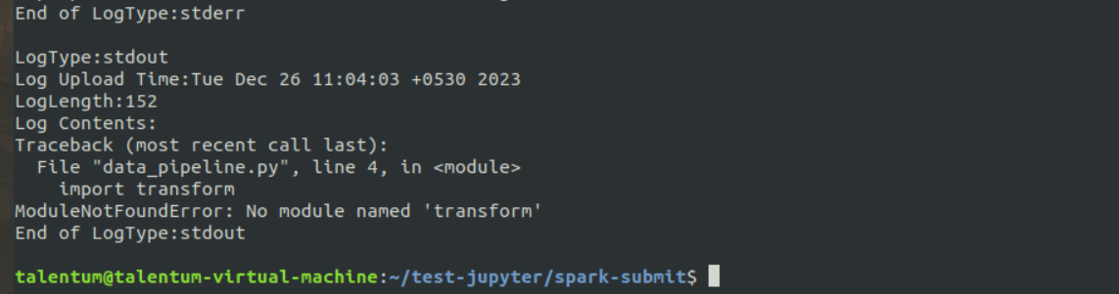

Spark Integration with Hive

1. Download the attached file in STAGING_AREA
2. Pull the file in LABS_AREA/test-jupyter/spark-hive

* Code/Dataset

data/Spark-Hive.zip

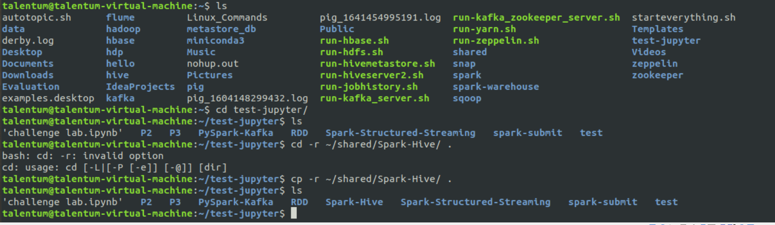



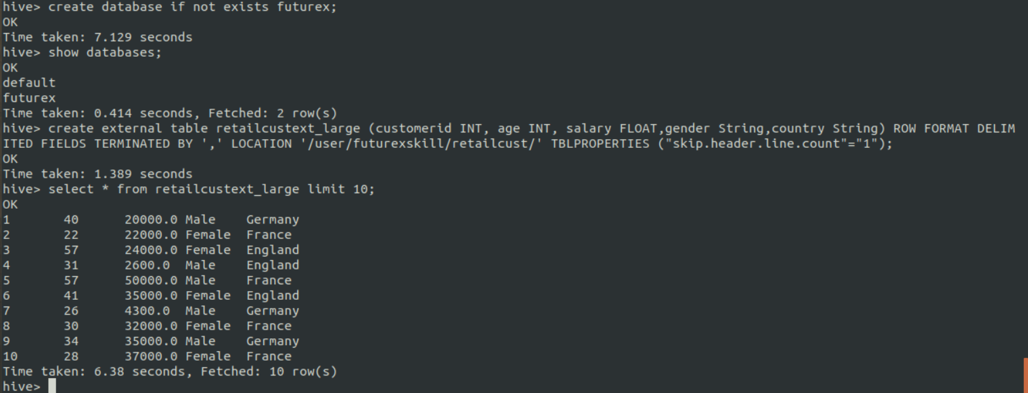

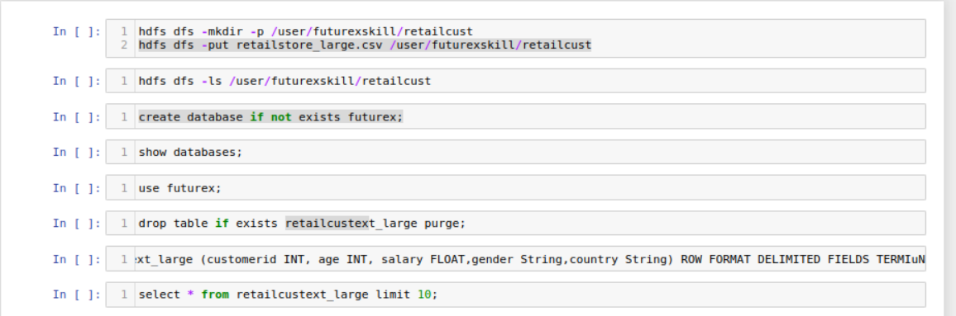

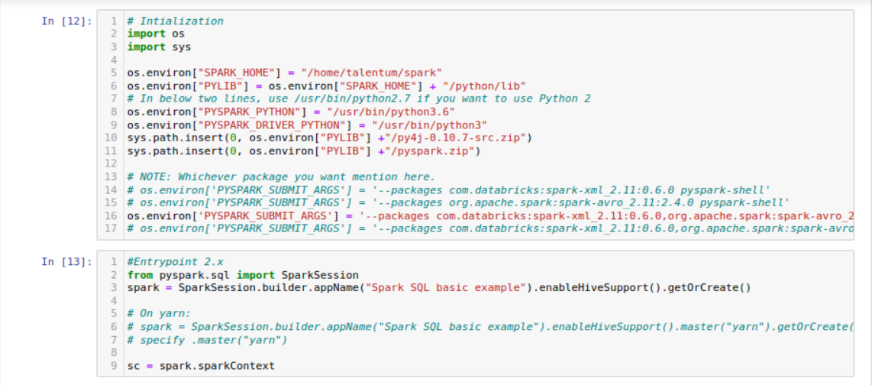

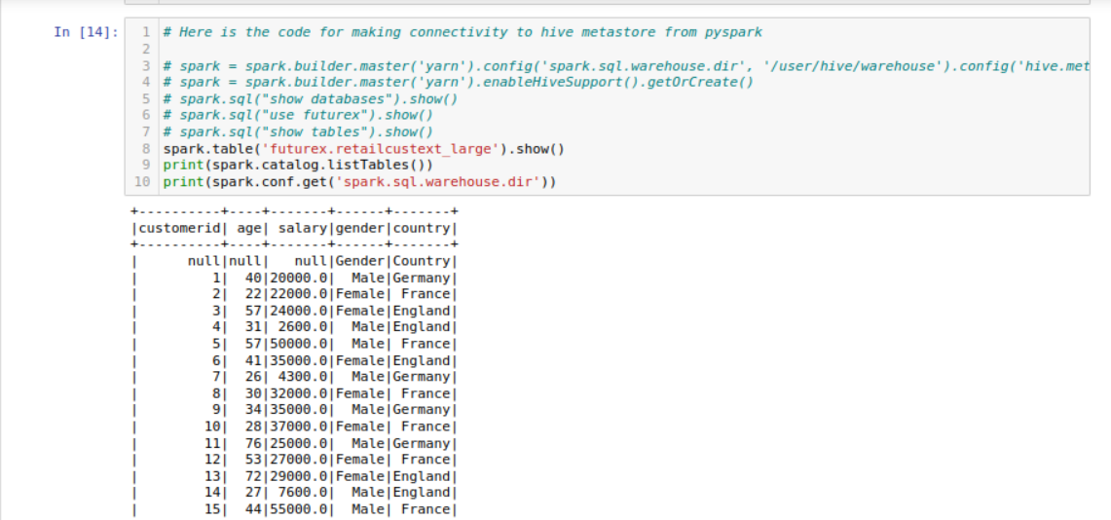

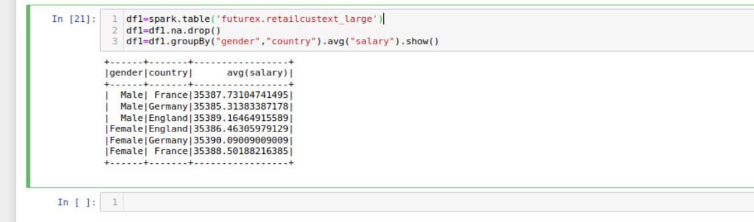

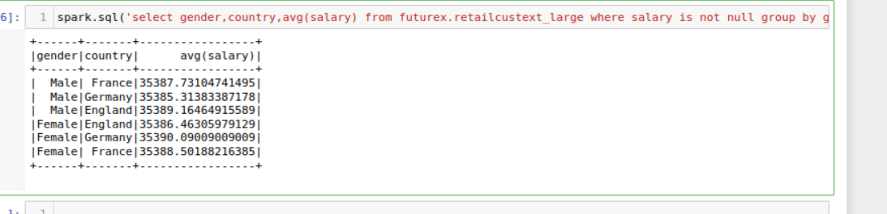



**Creating parquet file**

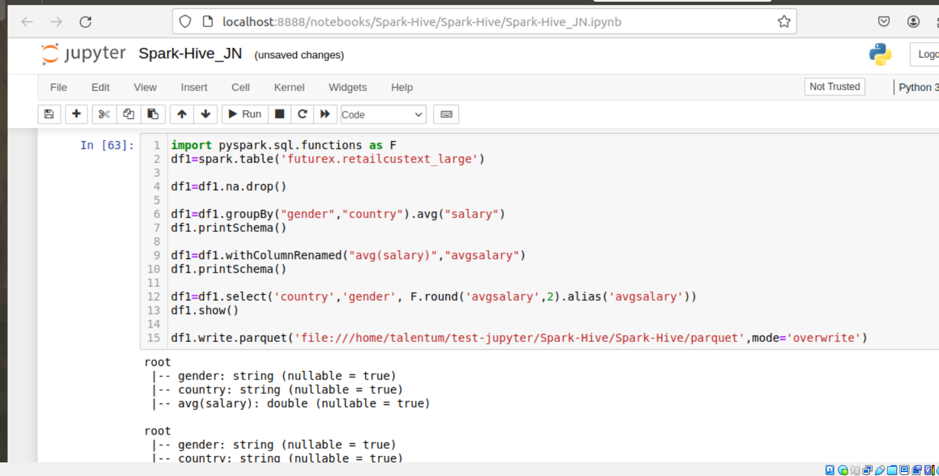

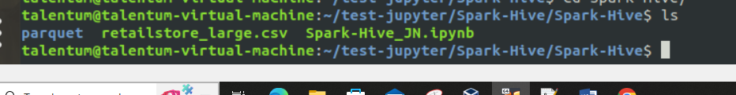

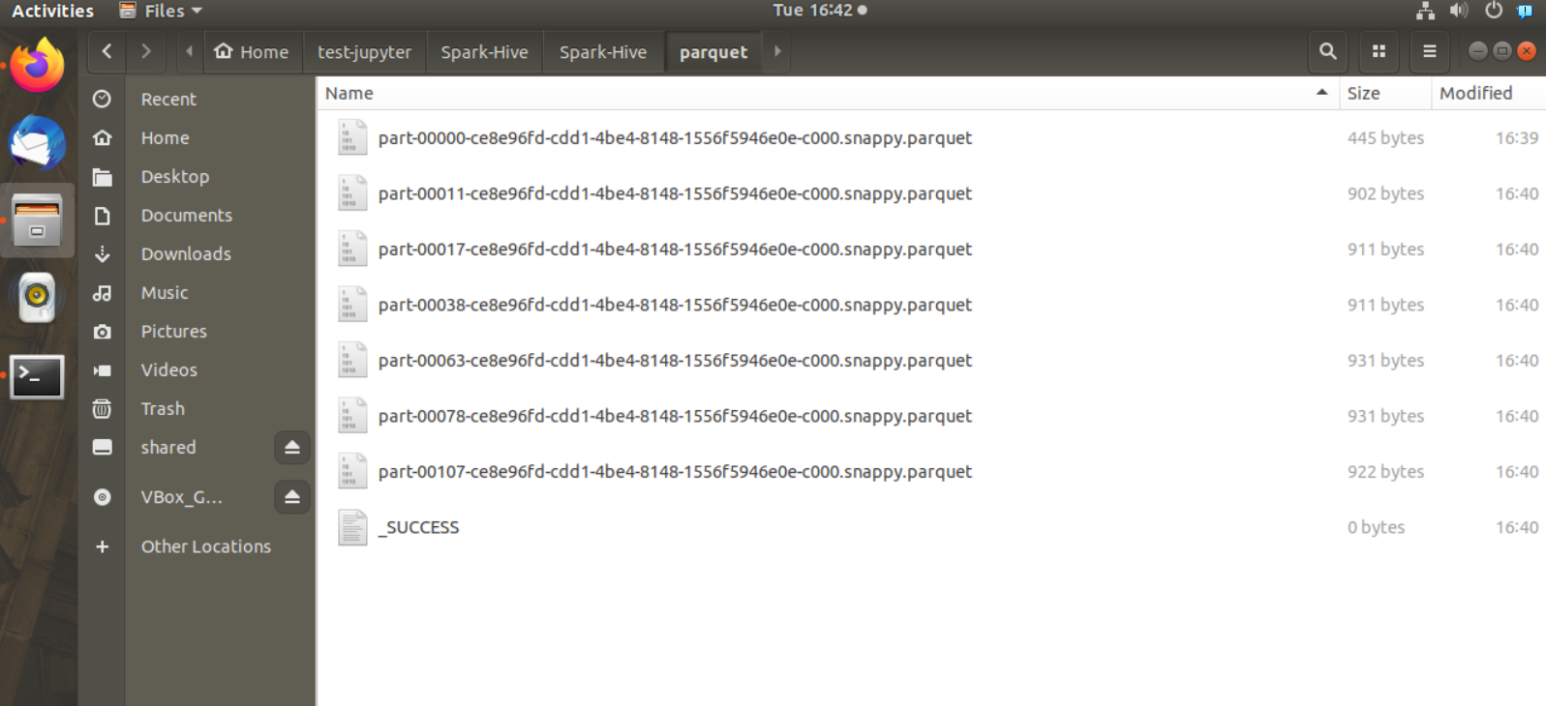

Spark JDBC

1. Download the attached file in STAGING_AREA
2. Pull the file in LABS_AREA/test-jupyter/spark-mysql

* Code/Dataset

data/Spark-MySql.zip

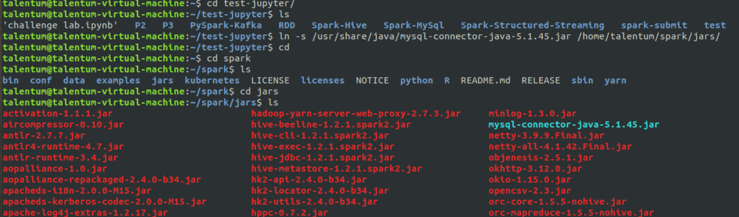

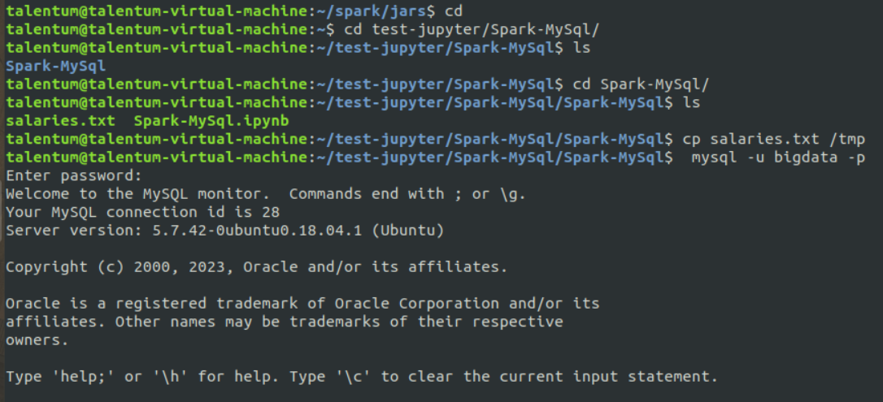

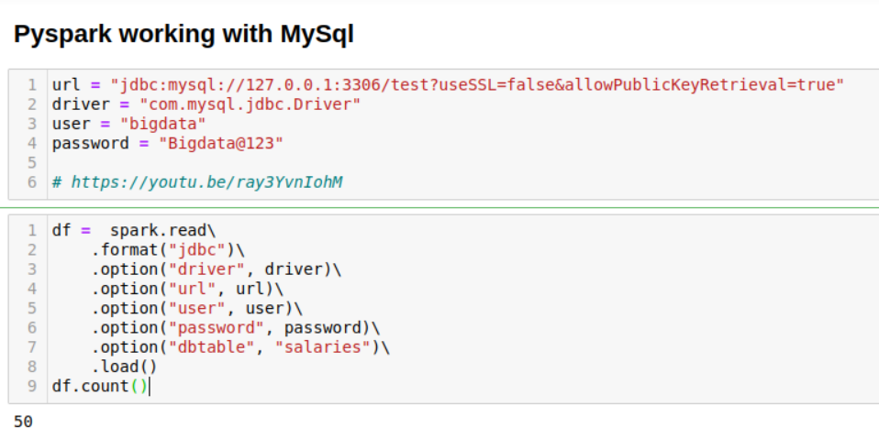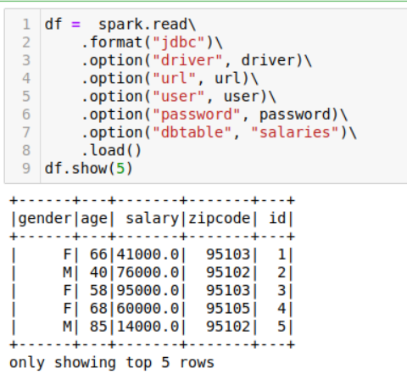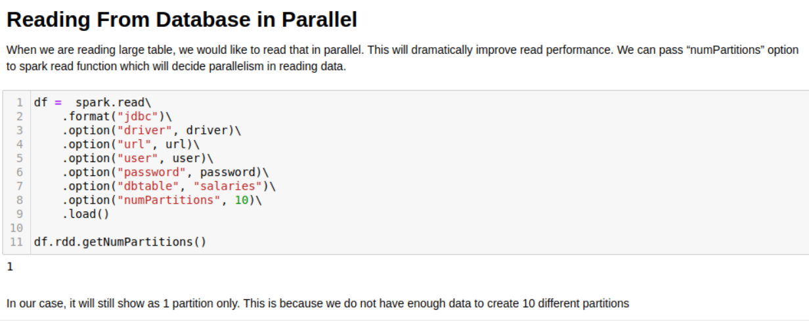

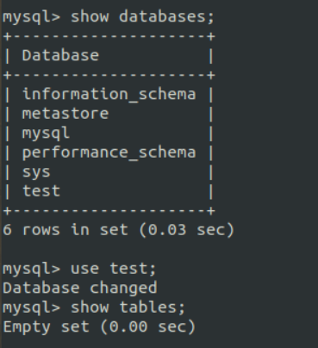

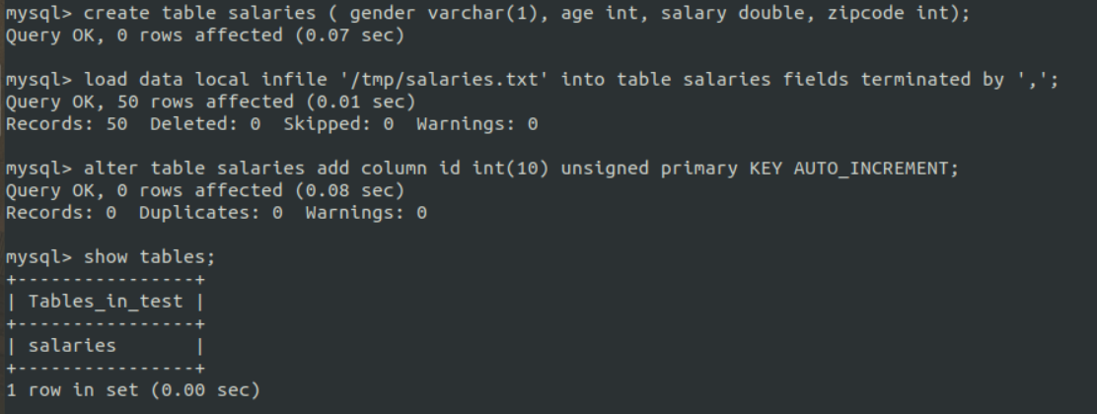

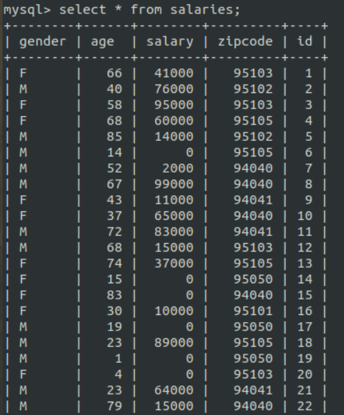

24] PySpark MlLib - Collaborative Filtering

1) Pull the extracted notes in UBUNTU_HOME/test-jupyter/P2/M4/SM2

2) Import the notes in the Jupyter notebook.

3) Follow the instructions based in the notes

* Code/Dataset

data/2_CollaborativeFiltering.rar

data/2_CollaborativeFiltering_Solution.rar

TimeLine = 25 Mins

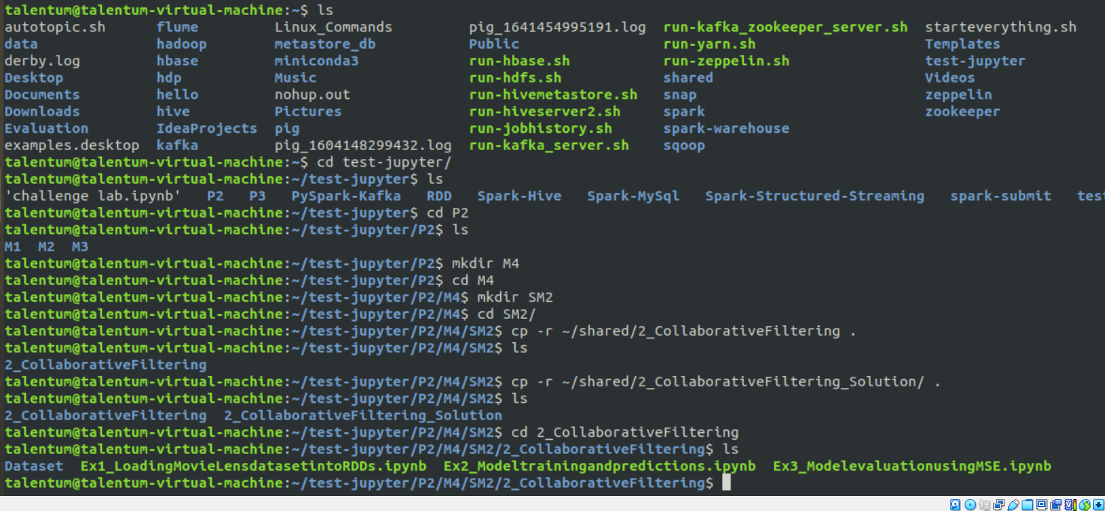

Pwd : /home/talentum/test-jupyter/P2/M4/SM2/2_CollaborativeFiltering

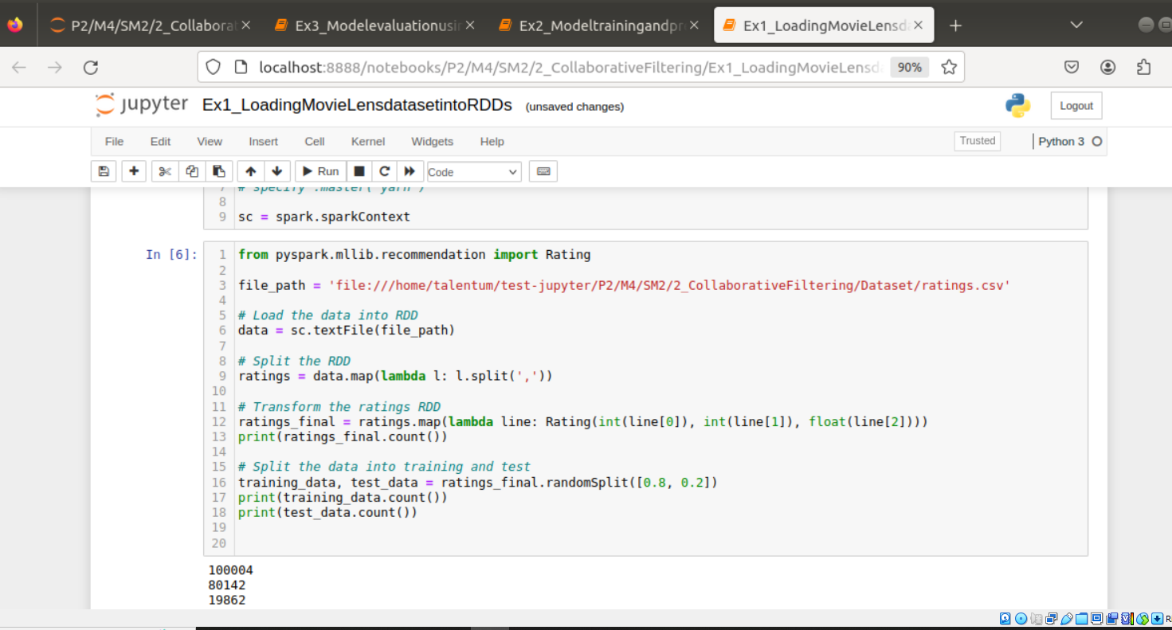

2.

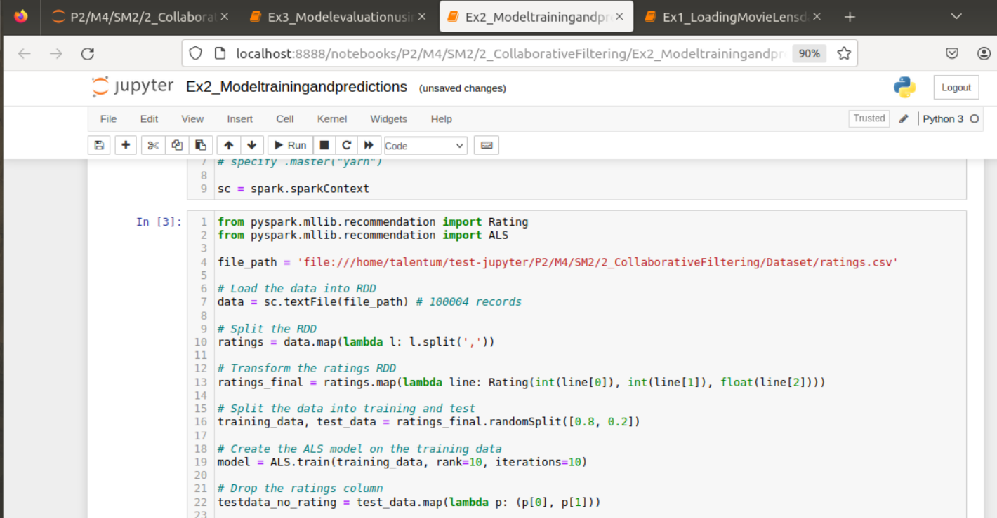

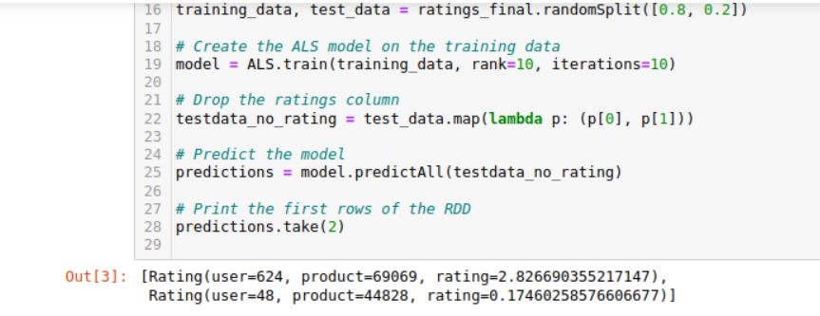

3.

